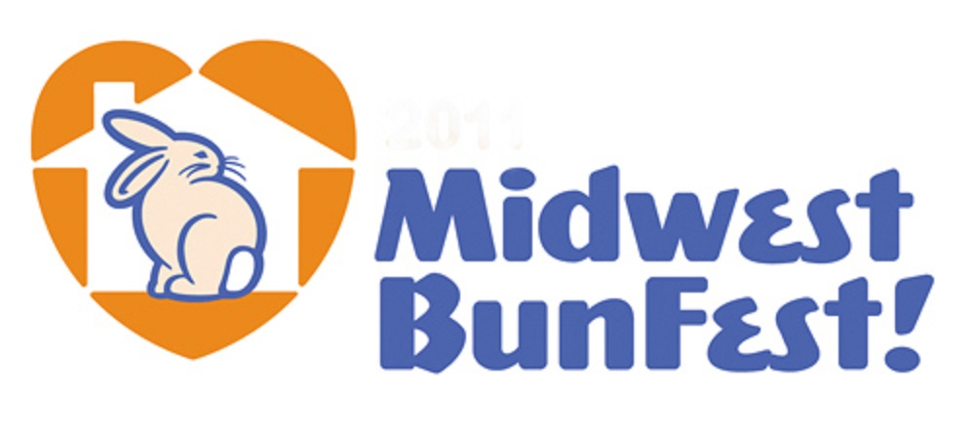

VENDOR INFORMATION PACKET AND APPLICATION FORM
As a business provider of products and services used by our supporters and by rabbit owners across the Midwest, Ohio House Rabbit Rescue (OHRR) invites you to apply to be a vendor at the Midwest BunFest 2017 in Columbus, Ohio on Saturday, October 14, 2017 at the Northland Performing Arts Center.

VENDOR BENEFITS

Vendors chosen for the event will receive:
- One to three 8’ rectangular table(s) or equivalent space and 2 chairs for display of merchandise, promotional materials, and signage
- Listing as an official Midwest BunFest 2017 vendor in selected event marketing and official communications, including emails and social media
- A website link for your company on the Midwest BunFest website
- Promotional posts for your business on social media websites, including the Midwest BunFest Facebook page
- 2 admission tickets to the event per table purchased

VENDOR TERMS OF AGREEMENT
- Ohio House Rabbit Rescue cannot guarantee that no other vendor will feature a similar product or service at Midwest BunFest 2017.
- Vendors are solely responsible for collecting, paying, and reporting all local, state, and federal taxes and fees associated with participation in this event.
- Associated costs of participation in this event such as travel, staffing, hotel accomodations, shipping, transportation, or any other liabilities incurred as a result of participation in the Midwest BunFest are the sole responsibility of the vendor and will not be reimbursed by Ohio House Rabbit Rescue.
- Requests for a specific table position/location at Midwest BunFest will be considered but specific placement is not guaranteed due to space requirements.
- Vendors will be responsible for set-up of their area, staffing of table(s) for the duration of the event, and tear-down of area.
- Vendors will donate one or more items to the silent auction/raffle.
- Midwest BunFest does not support the breeding of domestic rabbits for any reason, including but not limited to showmanship, ownership, or for the sale of meat. Please be advised that Midwest BunFest strictly prohibits the use of displays, promotional materials, or merchandise that promotes the breeding of domestic rabbits. Ohio House Rabbit Rescue reserves the right to remove displays, materials, or merchandise that it deems contrary to its mission or vision at any time during the event. Such decision will be final and the vendor agrees that the Ohio House Rabbit Rescue will not be liable for any costs, etc. associated with its decision.
Your signature on the registration/application form confirms your acceptance of these Terms of Agreement.

VENDOR SELECTION

- First-time Vendor Application Forms may be submitted via regular USPS or electronically via email (see form for further information). Selection of first-time vendors will be made at the sole discretion of the Midwest BunFest Planning Committee and will be based upon completion of application form and payment, suitability of your product and services for our audience, your business’s alignment with OHRR’s mission, and available space. You will be notified of acceptance by August 14.

- Returning Vendors Registration Forms may be submitted via regular USPS or electronically via email (see form for further information). You will be notified when we receive your registration form and then additional information will follow by August 14.

COST

Your vendor cost includes the following: 1-3 tables or equivalent floor space, plastic table cloth(s), 2 chairs, set-up and tear-down of tables, electricity, wireless Internet, and vendor addmission tickets. As in the past the costs for these services are subsumed under the “fee” for tables or equivalent floor space. The cost of one table or equivalent floor space is $75, two for $150 and three for $225.

Due to high demand and in hopes to accommodate everyone, we are limiting the number of tables and amount of floor space each vendor may use.
- No more than three 8’ rectangular tables--Please note, in previous years, folks have used considerable floor space with merchandise displays in addition to their table(s). If you plan on bringing your own floor displays, please limit the size to 8' floor space (roughly the size of one of the event tables).

- One 4’ x 4’ foot X-pen (or the equivalent floor space). Floor space for your bunny is free. This is in addition to the number of tables/equivalent floor space you request and is intended for an X-pen or other appropriate accommodations for our fuzzy friends. If you indicate on your vendor form that you will be bringing rabbit(s), we will automatically create a space adjacent to your table.

ACCESS TO ELECTRIC OUTLETS AND WIRELESS INTERNET
The Northland Performing Arts Center offers wireless access in the conference rooms, lobby and public areas.
One electrical outlet is available at each vendor area, mostly dropped down from the ceiling during the set-up of the tables prior to our arrival. Once the tables are set up in the room, we will not be able to “add” more cords or service. Vendors need to bring their own power strips, extension cords and adapters.

MARKETING AND SOCIAL MEDIA
We do quite a bit of social network messaging and advertising as we get closer to the event and would like to include messages about the vendors who will be at Midwest BunFest 2017. We typically post logos, with information about your shop, links to your website and pictures of the items you may be bringing with you for sale. This is a great time to drum up excitement for your store.
If you would like to be included in promotional messaging and on our Midwest BunFest website, please send us a copy of your logo (in .jpeg format) and a description of your shop, as soon as possible, so we can tell our "Followers" all about it. If you have a website or Facebook page that we can include, that would also be great. Pictures/logos/images should be sent as a .jpeg image with a sRGB color profile. Pictures and descriptions can be sent to us, via email at marybethparisi@gmail.com .

NEW VENDOR APPLICATION FORM

Thank you for your interest in being a vendor at Midwest BunFest on Saturday, October 14, 2017. Please complete this form and send it with your payment by July 28. You will be notified of your acceptance by August 14. Please feel free to contact us directly with any questions.

_____ Yes, I want to be a vendor for Midwest BunFest 2017.

_____ I cannot attend Midwest BunFest 2017, but want to contribute a Silent Auction item (see #8).

_____ I cannot attend Midwest BunFest in 2017, but keep me on your list.

Business name:

Business USPS mailing address:

Business telephone number: ( )

Business website:

Contact person's name:

Contact person’s title:

Contact person’s telephone number: ( )

Contact person’s email:
- Are your products/services offered for purchase online (e.g., website, Café Press, Etsy) ? _____ YES _____ NO
If YES, please provide address or link:
- What types of products and services do you offer (e.g., retail pet products, grooming services, veterinary services)?

- Please briefly describe what products and services you will be offering at Midwest BunFest 2017. (You may attach promotional materials, photographs or digital images, a brief description of your business and clients, customer segment focus, or other pertinent information.)

- Have you previously participated in similar events as a vendor? _____YES _____ NO
If YES, please list/describe:

- Do you need electricity at your table? _____ YES _____ NO

- Will you be bringing any bunnies with you to the event site? _____ YES _____ NO
If YES, we will automatically create a free 4’ x 4’ floor space adjacent to your table.

- Do you have any other special accommodations that you will need for your table/space (e.g., space in front of your table, location of table)? _____ YES _____ NO
If YES, please describe:

- Please provide any additional information you would llike us to know.

- VENDOR TERMS OF AGREEMENT—I have read and understand the terms of agreement as outlined on page 1 of the Vendor Information Packet.

Business Name:

Responsible Party’s Name and Title (Please Print):

Signature—We must have your signature (actual or electronic) in this space:

Date:

- SILENT AUCTION OR RAFFLE DONATION
Describe the silent auction or raffle item you will donate:
Estimate the value of the item you will donate: $
Please check one of the following:
_____ Item will be brought to the BunFest set-up day on Friday, October 13, 2017
_____ Item needs to be picked up (only if in Central Ohio)
_____ Item will be sent to OHRR at 611 Overbrook Drive, Columbus OH 43214

- REQUEST FOR TABLES OR EQUIVALENT SPACE—Please check the number of tables or equivalent space you need.
_____ One (1) for $75.00
_____ Two (2) for $150.00
_____ Three (3) for 225.00

- PAYMENT INFORMATION
Fees may be paid by check, PayPal or credit card upon application or no later than JULY 28, 2017.
_____ Check enclosed. (Please make check payable to Ohio House Rabbit Rescue)
_____ PayPal
_____ Credit card payment: Please check one _____ VISA _____ MasterCard _____American Express
Credit card number:
Expiration date:
Security Code:
Name on card:
Billing address:

I, , authorize Ohio House Rabbit Rescue to charge $ to this card.
(Name) (Amount)

(Cardholder’s signature—required; actual or electronic) (Date)

Send form with payment by July 28 to:
OHRR/Midwest BunFest, 611 Overbrook Drive, Columbus, OH 43214
or
email to: dican49@aol.com
If you have questions, please contact
Diane Cantrell, Vendor Coordinator at dican49@aol.com

